Task Manager-Exercise 001

- Task Manager:is a Windows tool used to monitor applications, processes and system performance. It can be used to identify programs that are using excessive CPU, RAM, Disk
- CPU:The CPU is the processor and is often called the brain of the computer. It executes instructions, performs calculations and processes data required for programs and the operating system to run.
CPU = 3%
The processor is under a very light workload and has plenty of available capacity.
CPU = 70–99%
The processor is working under a heavy workload. This can make the computer slow or unresponsive.

Common causes:
- Too many applications running
- Multiple Chrome tabs open
- Windows Updates
- Antivirus scans
- Software installation
- Faulty or resource-intensive applications

- RAM:RAM is temporary memory used by the operating system and applications while the computer is running. It allows programs to access data quickly.
RAM = 20%
Plenty of available memory remains.
RAM = 95–100%
The computer is running low on available memory, which may cause slow performance.
Common causes:
- Too many browser tabs
- Multiple applications open
- Video editing software
- Large files or virtual machines

- Disk: it stores data data permanentley, windows photos, videos, documents, games, applictions and how hard is the storage drive is currently working a high % means the hard drive is very busy this makes the computer slow new softwares updating windows, antivirus scans and file transfers espically make it slow, reading and writing files, dowalading videos files all slow it down
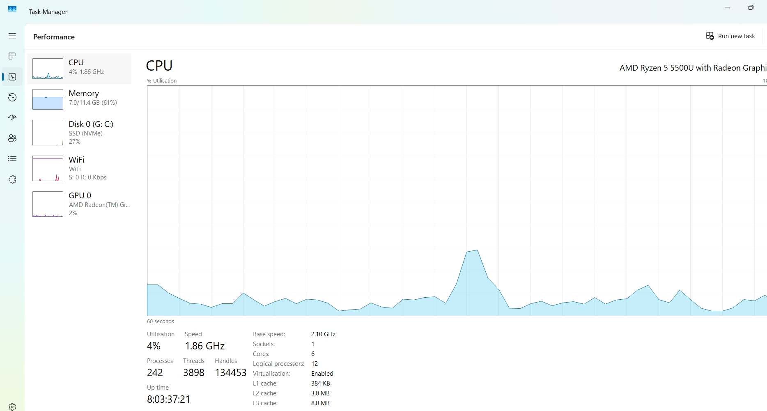

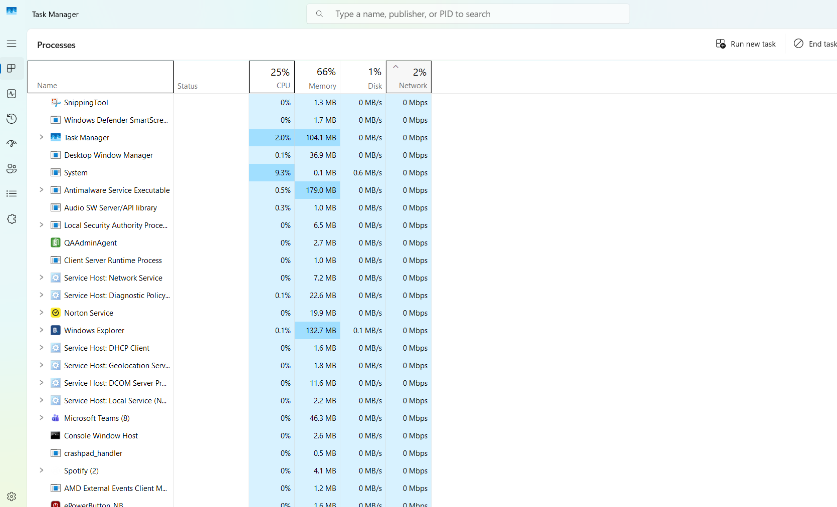
- Device Manager:Is a windows tool used to view and troublesshoot hardware and drivers you can use it if your mouse isnt working keyboard isnt working you access it by going into search bar and typing Device Manager
- Drivers: Are softwares or files your pc uses too commuicte with hardware
- User accounts:is used manage users passwords and permisson user needs a new account, user cant login, user, foregt password,you access it by goint into setting and finding account
- has full system control too a standarder user that cannot changes systerm settings.Admistotor grants permision and has control over other users and system
- Event Viewer:is tool used too invisgate past errors warning and systems failures you access it by going into search bar and typing event viewwe

